# How to get a working Sonar plugin project in Eclipse

In that what follows we explain every detail. Just skip a section if you think you still have done that what the regarding section focuses.

## Install Java Development Kit

Select and download the current JDK to install it to your system. If java is ready make sure that the following system variables exist:

JAVA_HOME = C:\Program Files\Java\jdk1.7.0_09 (change the path to your JDK install path)

Also you must add your JAVA_HOME variable (add *\bin* ) to your path variable.

*PATH =…;%JAVA_HOME%\bin\;*

## Install maven

Download the current maven binary to your system:

<http://maven.apache.org/download.html>

Extract it somewhere and after this create following Path variables:

*M2_HOME = C:\Program Files\apache-maven-3.0.4 (change the path to your maven folder)*

*M2 = %M2_HOME%\bin*

Next step is to add M2 to your path variable.

*PATH = …%M2%;*

## Get a working Eclipse version

We recommend an actual eclipse Version. We use Eclipse Juno (4.2) for Java developer. You can get it at

<http://www.eclipse.org/downloads/>

Remember to select the correct version for your system.

## Install maven plugin for eclipse

Install via

**Help -> Install New Software…**

Now select/add the repository of you eclipse version. In our example we’ll use

**http://download.eclipse.org/releases/juno**

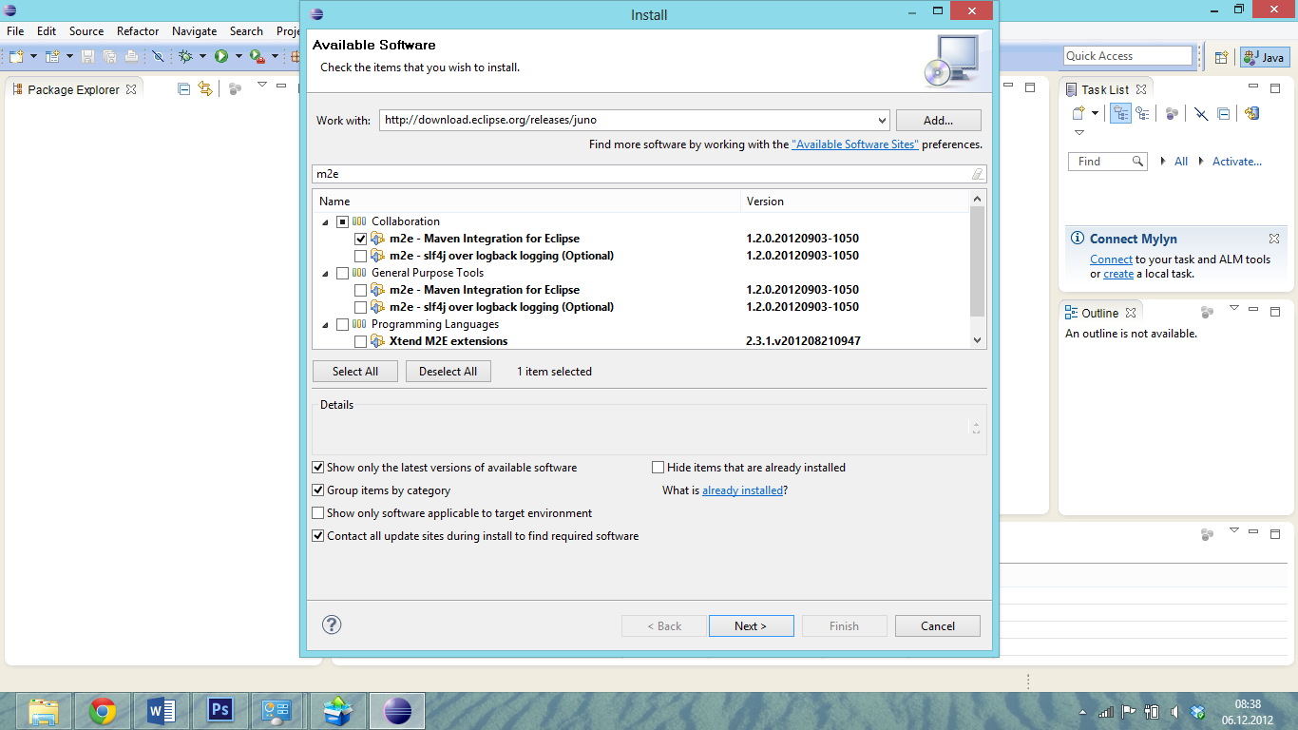

Select **m2e – Maven Integration for Eclipse** click through the progress to install the plugin. If everything works well eclipse will ask you for an eclipse restart.

## Get the example plugin from GitHub and use it as an Eclipse Project

Download the following copy of our repository:

<https://github.com/arsenij-solovjev/sonar-modelbus-plugin/archive/master.zip>

Extract the archive and if you like copy the folder **sonar-modelbus-plugin-master** a special folder. It’s just important that u don’t copy this folder in your workspace.

Now create a new Eclipse project

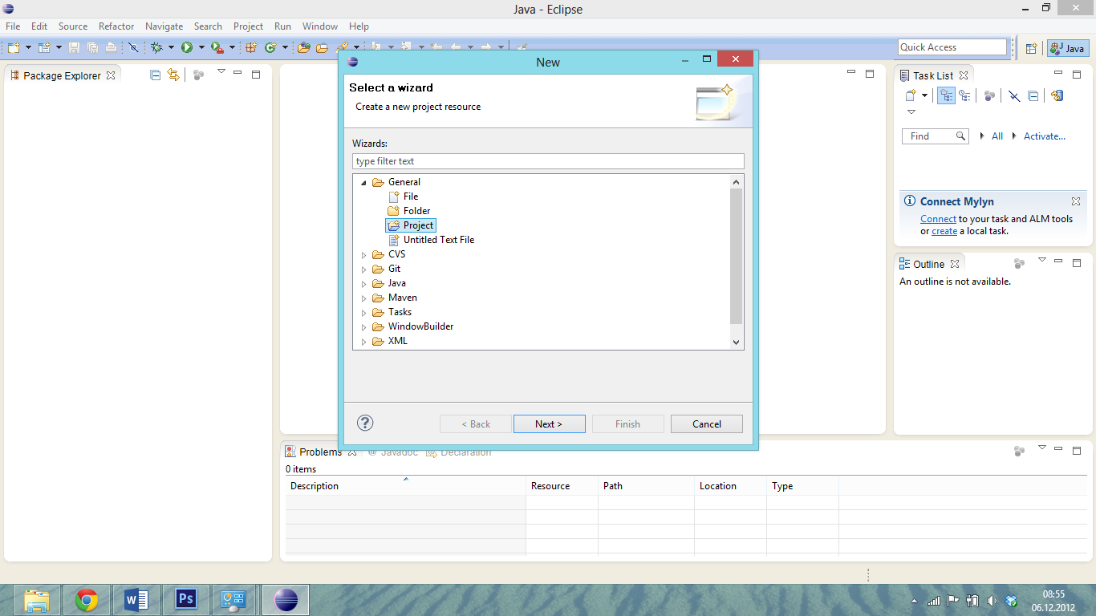

Unselect the **Use default location** box and select the **sonar-modelbus-plugin-master** folder. Don’t forget to choose a project name.

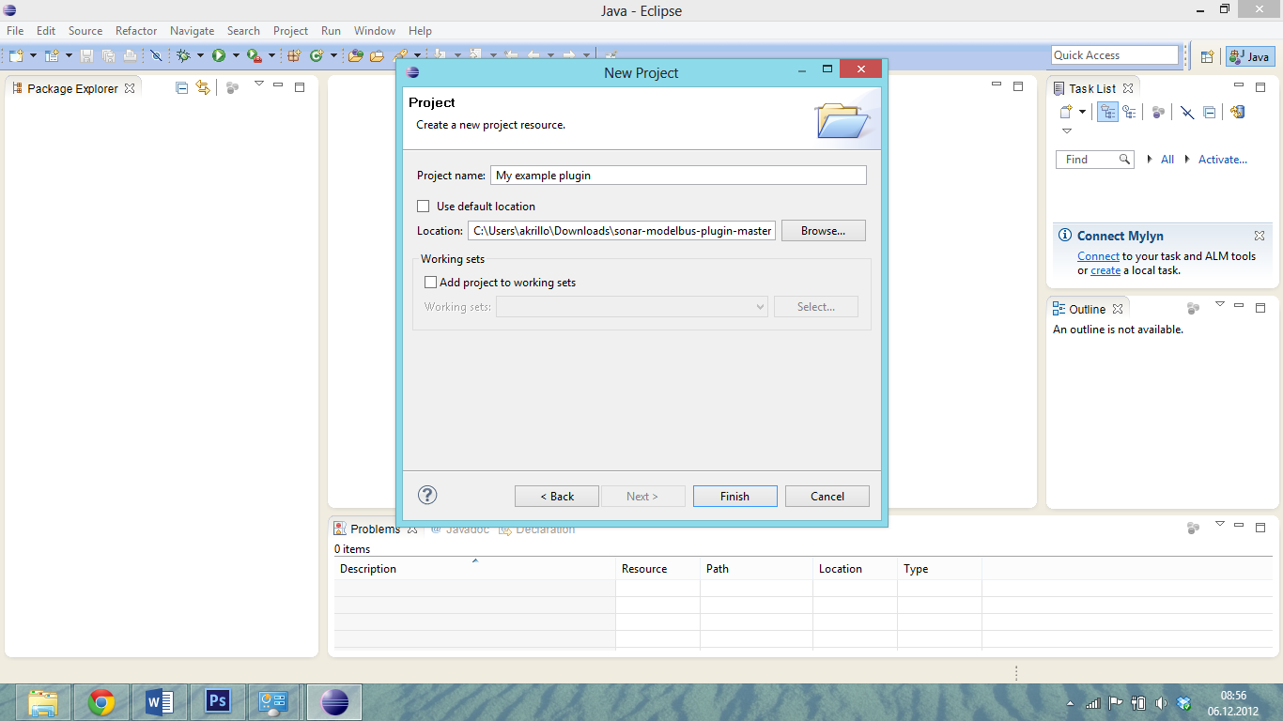

*Notice: If you finish the project creation process you may get “EGit could not detect where GIT is installed” or “Check HOME directory” warning but it doesn’t matter in this case.*

## Convert your project to a maven project and prepare it for future execution

Right click to your project folder and choose:

**Configure -> Convert to Maven Project**

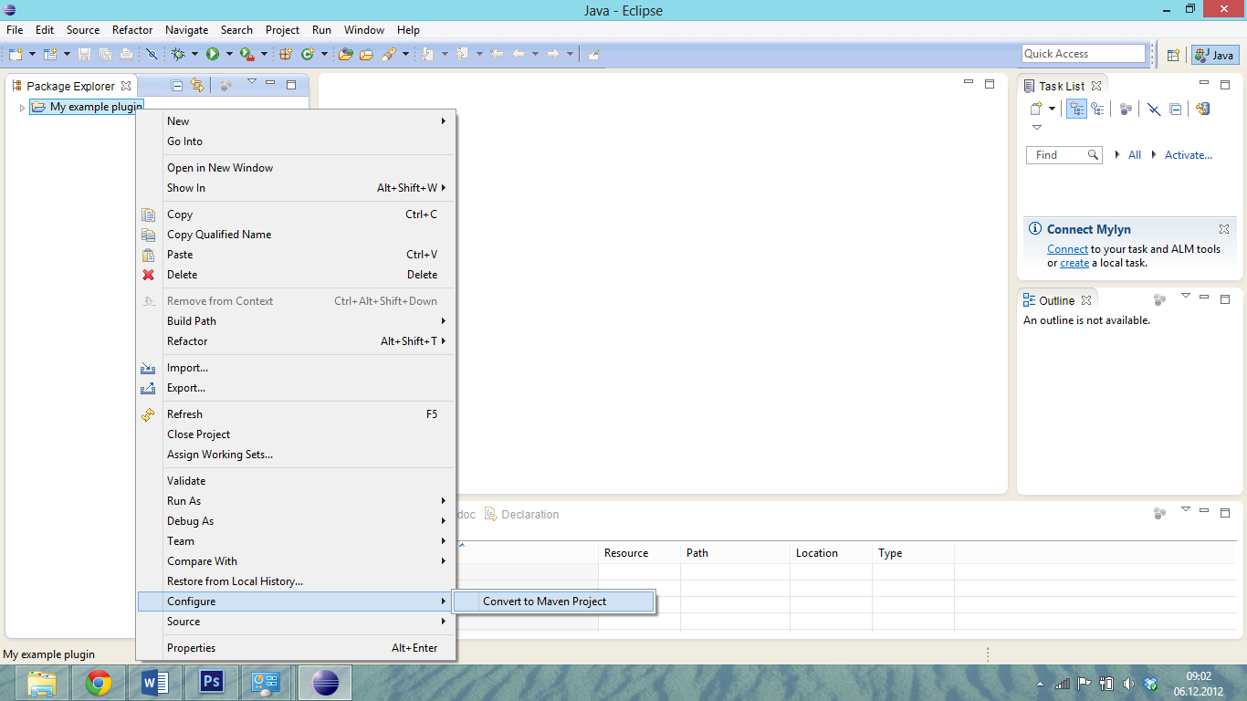

*Notice: If you get any error ( this is not unusual ) just ignore it. If you can’t do the next step just repeat the previous step*

Next step is right click your project again, select **Run as -> Maven install** .

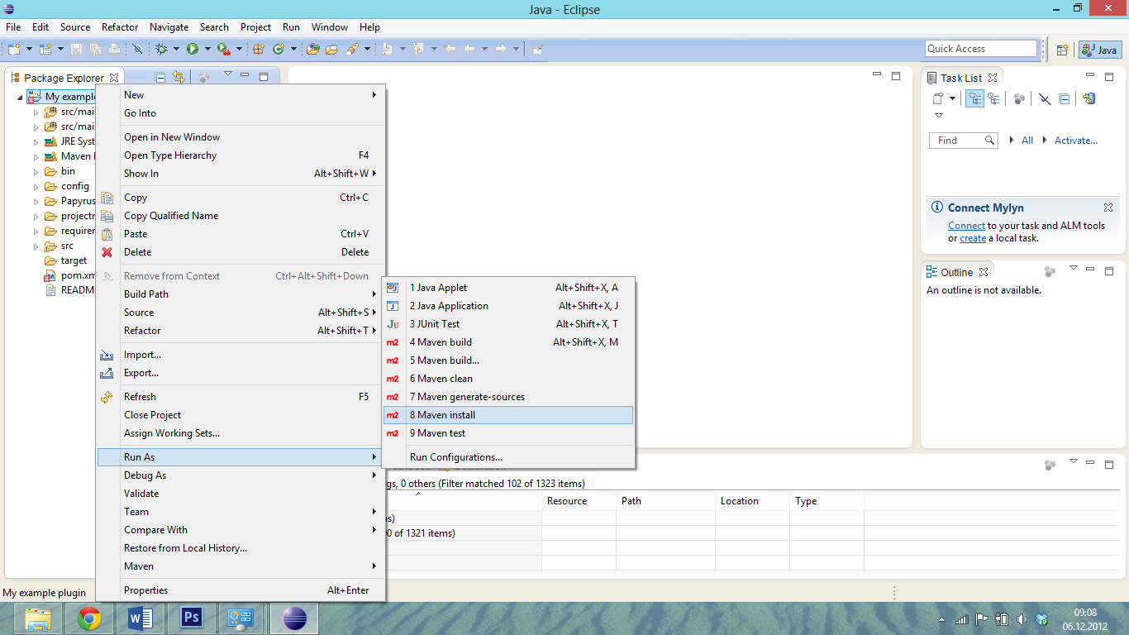

If everything works well you see some reports like this:

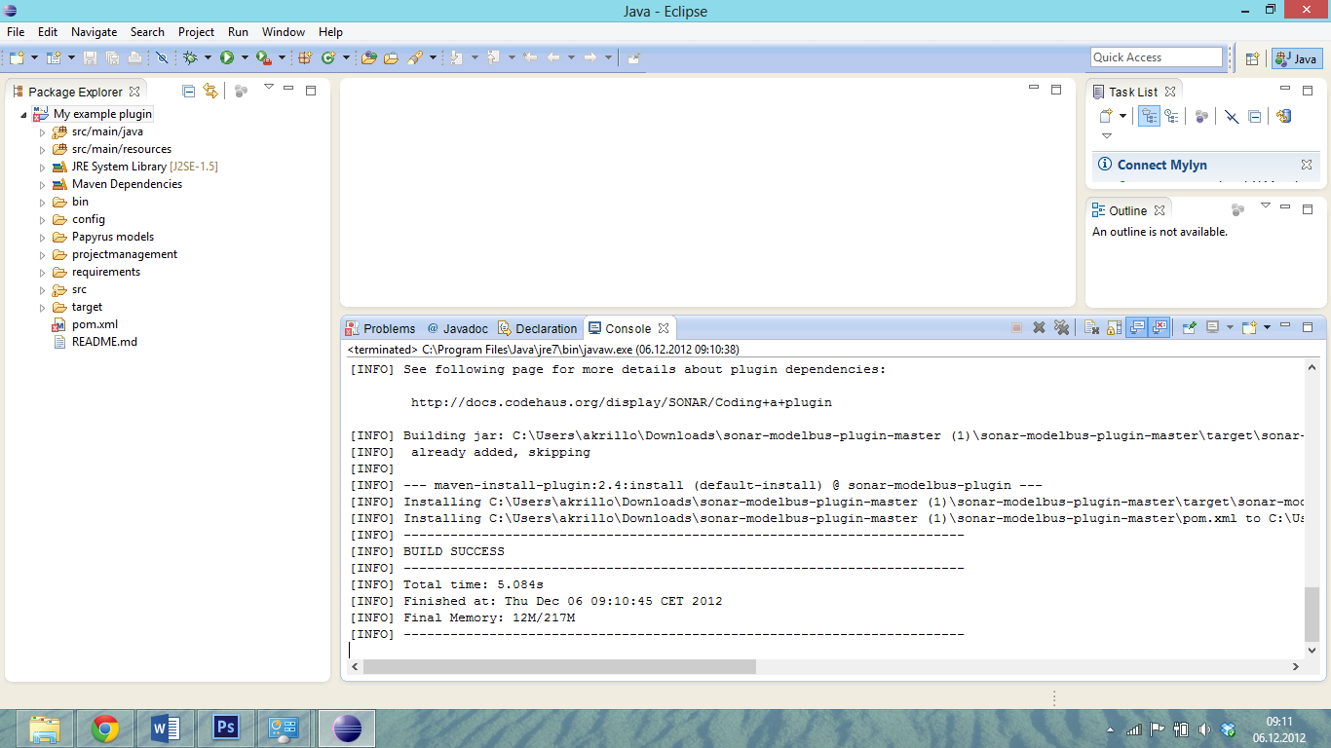

## Start Sonar with the example plugin via eclipse

To run Sonar with our example plugin we need to build the maven project. Right click your Project and select **Run as -> Maven Build…**

In **Goals** you paste

org.codehaus.sonar:sonar-dev-maven-plugin::start-war -Dsonar.runtimeVersion=3.1

and press **Run** to start the build process and run Sonar.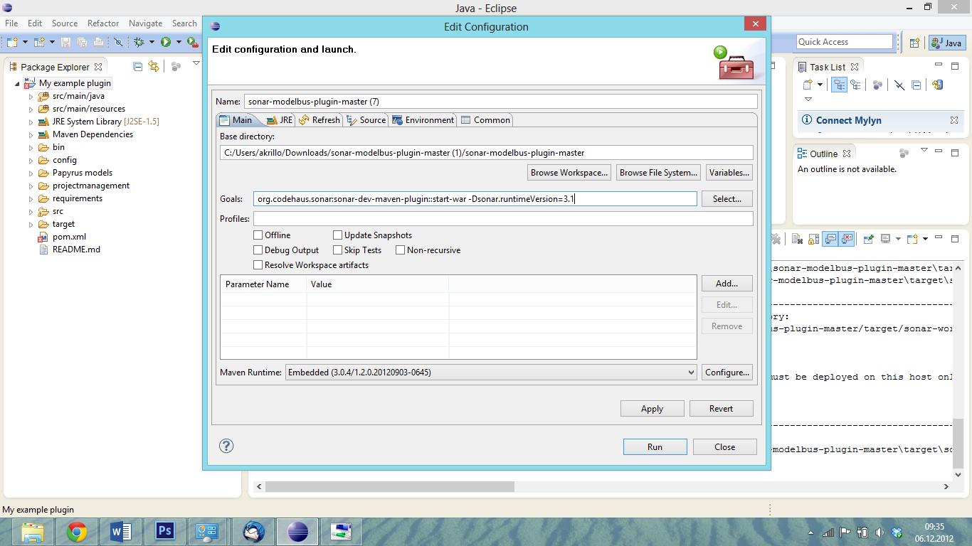

*Notice: this can take some minuets and if it seems to be frozen just restart the build process. If some errors occur just restart.*

Sometimes you’ll get an error like this:

*[INFO] ------------------------------------------------------------------------*

*[INFO] BUILD FAILURE*

*[INFO] ------------------------------------------------------------------------*

*[INFO] Total time: 36.523s*

*[INFO] Finished at: Fri Dec 07 14:54:12 CET 2012*

*[INFO] Final Memory: 12M/160M*

*[INFO] ------------------------------------------------------------------------*

*[ERROR] Failed to execute goal org.codehaus.sonar:sonar-dev-maven-plugin:1.6:start-war (default-cli) on project sonar-modelbus-plugin: Failed to execute: Executing Ant script: dev.build.xml [start-war]: Failed to execute. The following error occurred while executing this line:*

*[ERROR] C:\Users\akrillo\AppData\Local\Temp\plexus-ant-component1642284228033867161.build.xml:252: The following error occurred while executing this line:*

*[ERROR] C:\Users\akrillo\AppData\Local\Temp\plexus-ant-component1642284228033867161.build.xml:266: The following error occurred while executing this line:*

*[ERROR] C:\Users\akrillo\AppData\Local\Temp\plexus-ant-component1642284228033867161.build.xml:521: Execute failed: java.io.IOException: Cannot run program "C:\Users\akrillo\Downloads\sonar-modelbus-plugin-master\sonar-modelbus-plugin-master\EMBEDDED\bin\mvn.bat": CreateProcess error=2, Das System kann die angegebene Datei nicht finden*

*[ERROR] -> [Help 1]*

To hotfix this issue on the required location you can create the requested file mvn.bat with the following content:

*call "C:\Program Files\apache-maven-3.0.4\bin\mvn.bat"*

This path should be your maven path.

If everything went fine you’ll see some status messages:

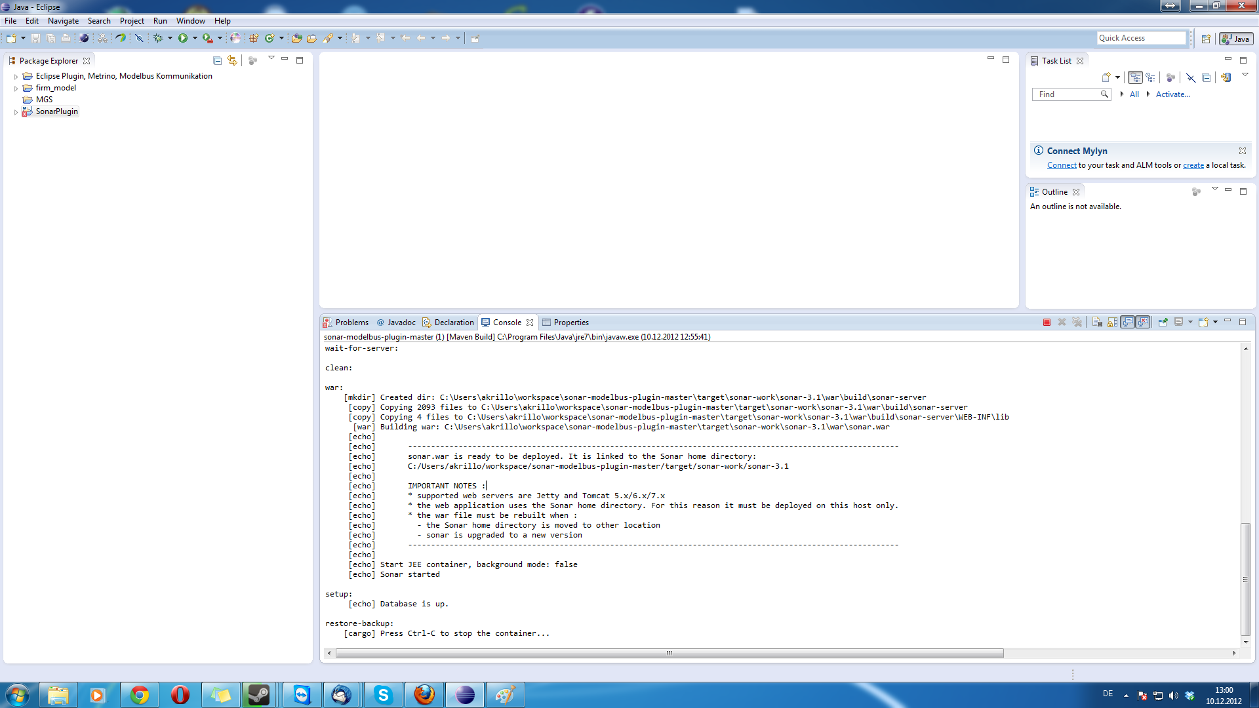

Now you can check <localhost:9000> in your browser.

You’ll see a running sonar version. If you like to analyse your project you can start a build process with the gold:

*Sonar:sonar*

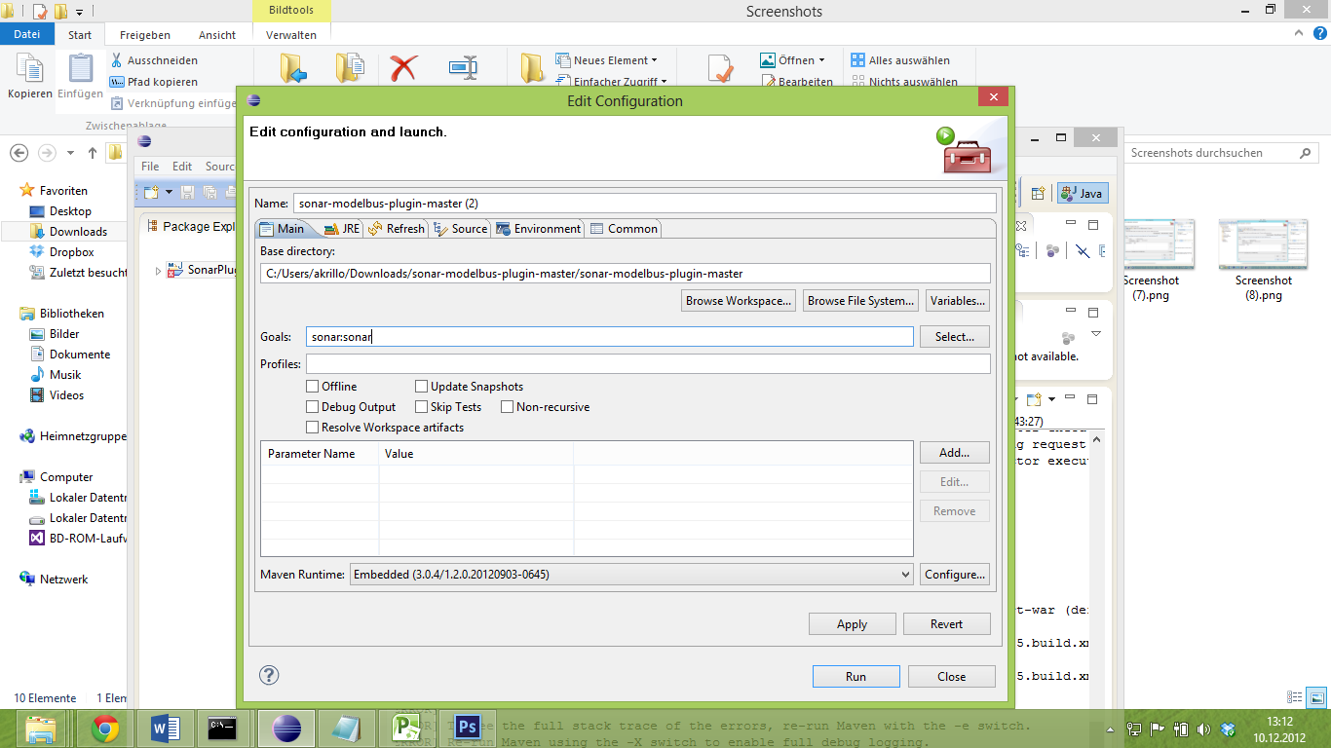

*After he’s done you refresh your* <localhost:9000> uri and u’ll see some analystics.

Now you can start developing your plugin in eclipse and start a Sonar version that use your plugin.